# Data Centric RAD

## Lab 7 MongoDB Driver

### Setup

1. To start Mongodb firstly run the mongod command as follows:

C:\Program Files\MongoDB\Server\3.4\bin>mongod

1. Then run the mongo command as follows to open the shell:

C:\Program Files\MongoDB\Server\3.4\bin>mongo

1. Create a mongodb database called usersdb.

use usersdb;

1. Create a collection called users2 with the following data:

|  |  |  |  |  |  |  |  |
| --- | --- | --- | --- | --- | --- | --- | --- |
| **_id** | **fname** | **surname** | **age** | **email** | **sex** | **title** | **car** |
| 100 | John | Smith | 35 | jsmith@gmail.com | M | Mr | Reg: 131-G-101  Fuel:petrol |
| 101 | Sean | Murphy | 22 | [seanmurph@yahoo.com](mailto:seanmurph@yahoo.com) | M | Mr |  |
| 102 | Aine | Browne | 23 | abrowne@gmail.com | F | Ms |  |
| 103 | Alan | Murphy | 25 | [murpha@hotmail.com](mailto:murpha@hotmail.com) | M |  |  |
| 104 | Sarah | Doyle | 24 | sarah@gmail.com | F |  | Reg:141-MO-123  Fuel:diesel |
| 105 | Bill | Mulligan | 20 | [billy123@gmail.com](mailto:billy123@gmail.com) | M |  | Reg: 12-RN-445  Fuel:Petrol |
| 106 | Shane | Kelly | 25 | sk998@yahoo.com | M | Mr | Reg: 11-WH-7783  Fuel:petrol |
| 107 | Will | Doyle | 20 | doyler123@yahoo.com | M | Mr |  |

db.users2.save({_id:100, fname:"John", surname:"Smith", age:35, email:"jsmith@gmail.com", sex:"M", title:"Mr", car:{reg:"131-G-101", fuel:

"petrol"}})

db.users2.save({_id:101, fname:"Sean", surname:"Murphy", age:22, email:"seanmurph@yahoo.com", sex:"M", title:"Mr"})

db.users2.save({_id:102, fname:"Aine", surname:"Browne", age:23, email:"abrowne@gmail.com", sex:"F", title:"Ms"})

db.users2.save({_id:103, fname:"Alan", surname:"Murphy", age:25, email:"murpha@hotmail.com", sex:"M"})

db.users2.save({_id:104, fname:"Sarah", surname:"Doyle", age:24, email:"sarah@gmail.com", sex:"F", car:{reg:"141-MO-123",fuel:"diesel"}})

db.users2.save({_id:105, fname:"Bill", surname:"Mulligan", age:20, email:"billy123@gmail.com", sex:"M", car:{reg:"12-RN-445",fuel:"petrol"

}})

db.users2.save({_id:106, fname:"Shane", surname:"Kelly", age:25, email:"sk998@yahoo.com", sex:"M", title:"Mr", car:{reg:"11-WH-7783",fuel:

"petrol"}})

db.users2.save({_id:107, fname:"Will", surname:"Doyle", age:20, email:"doyler123@yahoo.com", sex:"M", title:"Mr"})

### Part 1

1. Write a Java application that connects to the Mongo database and collection just created and prints out (to the console) all details of each document, for example:

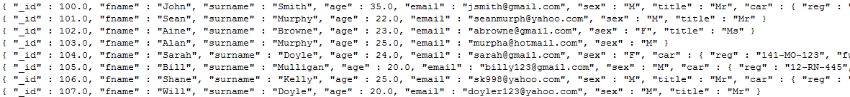

1. Write a Java application that connects to the Mongo database and collection just created and prints out (to the console) only the first name, surname and age attributes of each document, for example:

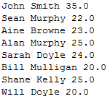

1. Write a Java application that connects to the Mongo database and collection just created and prints out (to the console) full details of all documents where the user’s is older than 20 years of age, for example:



1. Write a Java application that connects to the Mongo database and collection just created and adds the following Users:

|  |  |  |  |  |  |  |  |
| --- | --- | --- | --- | --- | --- | --- | --- |
| **_id** | **fname** | **surname** | **age** | **email** | **sex** | **Title** | **car** |
| 400 | Billy | Collins | 23 | billy63@hotmail.com | M | Mr | Reg: 172-G-1123  Fuel:diesel |
| 401 | Mary | Behan | 27 | [mary@gmail.com](mailto:mary@gmail.com) | F | Ms |  |

NOTE: The user details can be hard-coded in the application.

1. Write a Java application that connects to the Mongo database and collection just

created and deletes the document with _id = 102.

1. Write a Java application that connects to the Mongo database and collection just created and gets full details of all documents.

Each document should be stored in an associated User object.

In each User object where the fuel type of Car is “petrol”, it should be changed to “electric”.

The entire list of objects should be printed out as shown below.

NOTE: There is no need to change the fuel type in the mongo database.

